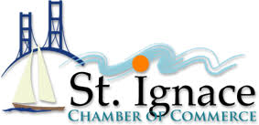

Auction Donation Request Form

Company Name: _________________________________________

Contact name: ___________________________________________

Email: ____________________________________________________

Phone: ___________________________________________________

Address: _________________________________________________

Item: _____________________________________________________

Fair Market Value: ______________________________________

Suggested Minimum bid: ________________________________

Member Appreciation Banquet will be held October 9th

At Kewadin Casino and Hotels in St. Ignace.

Please return form and donation to:

560 N. State Street

St. Ignace, MI 49781

906-643-8717

Or fax to: 906-643-9380

Or send to: [info@saintignace.org](mailto:info@saintignace.org)

We will pick up donations upon request